EDA Report
Retail Sales Performance Analysis
ABC Retail Pvt Ltd

1. Introduction
This report presents an Exploratory Data Analysis (EDA) of the retail sales dataset for ABC Retail Pvt Ltd. The company operates across four regions (North, South, East, West) and sells products in five categories: Electronics, Furniture, Clothing, Grocery, and Sports.
The goal of this analysis is to understand sales patterns, identify top performing regions and categories, study monthly trends, and provide business recommendations based on the data.

2. Dataset Overview
Total Records: 1000 orders
Time Period: January 2025 to December 2025
Columns: Order_ID, Order_Date, Region, Product_Category, Sales, Profit, Discount
Missing Values: None (dataset is clean)
Duplicate Records: None

Two additional columns were added during data cleaning:
- Month: numeric month extracted from Order_Date
- Month_Name: abbreviated month name for readability

2.1 Basic Statistics
Metric | Sales | Profit | Discount
Minimum | 1,016 | 116 | 0%
Maximum | 49,787 | 14,982 | 40%
Mean | 24,793 | 7,400 | 20.5%
Median | 24,622 | 7,367 | 21%

3. Problem Analysis and Findings

Problem 1: Total Sales by Region
We calculated total sales for each of the four regions to identify the highest and lowest performing regions.

Region | Total Sales | Rank
West | 66,20,673 | 1st (Highest)
South | 65,20,920 | 2nd
East | 61,65,086 | 3rd
North | 54,85,839 | 4th (Lowest)

Observation: West region leads in total sales followed closely by South. North has the lowest sales and may need more marketing focus.

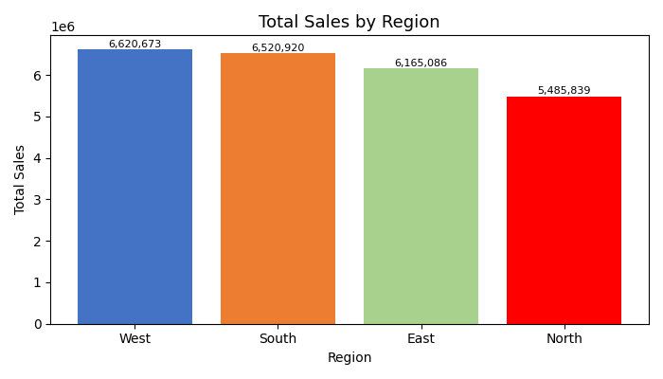

Problem 2: Total Profit by Product Category
We grouped data by product category and summed profit to find the most profitable category.

Category | Total Profit | Rank
Sports | 16,11,520 | 1st
Clothing | 15,55,492 | 2nd
Electronics | 15,14,398 | 3rd
Furniture | 14,55,494 | 4th
Grocery | 12,63,568 | 5th

Observation: Sports generates the highest profit, while Grocery has the lowest profit margin among all categories.

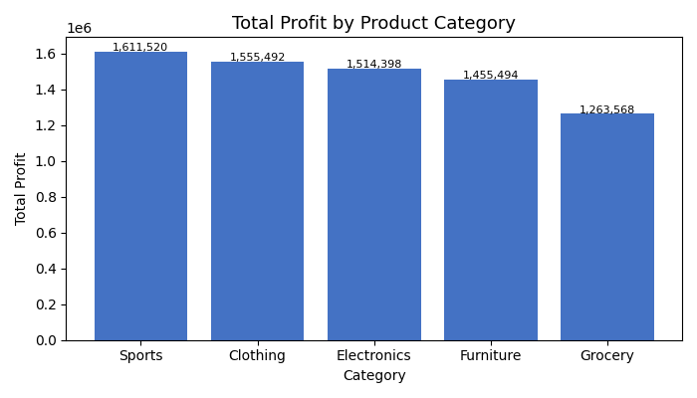

Problem 3: Average Discount by Region
Region | Average Discount (%)
South | 21.90%
East | 20.03%
West | 19.99%
North | 19.85%

Observation: South region gives the highest average discount. This might explain why it has slightly lower revenue relative to its order volume.

Problem 4: Top 10 Highest Sales Orders
Order ID | Region | Category | Sales | Profit
1629 | West | Furniture | 49,787 | 3,636
1741 | North | Electronics | 49,777 | 14,046
1376 | North | Furniture | 49,752 | 12,065
1300 | West | Sports | 49,735 | 14,921
1894 | North | Furniture | 49,628 | 8,932
1306 | North | Clothing | 49,543 | 7,371
1779 | South | Grocery | 49,382 | 2,086
1659 | West | Sports | 49,322 | 3,773
1711 | North | Grocery | 49,211 | 5,552
1478 | East | Furniture | 49,196 | 7,625

Observation: High sales do not always mean high profit. Order 1629 (West, Furniture) had the highest sales of 49,787 but a relatively low profit of 3,636. This suggests heavy discounting on large orders.

Problem 5: Monthly Sales Trend
March recorded the highest sales (24,07,195) while February had the lowest sales (16,76,001). There is a clear peak in the first quarter especially March, and again around July-September.

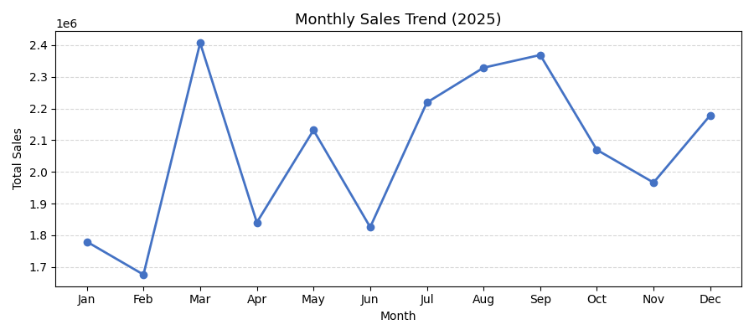

Problem 6: Monthly Profit Trend
March was also the most profitable month (7,44,206) followed by May (7,39,495) and December (7,20,576). October was the least profitable month (5,19,682).

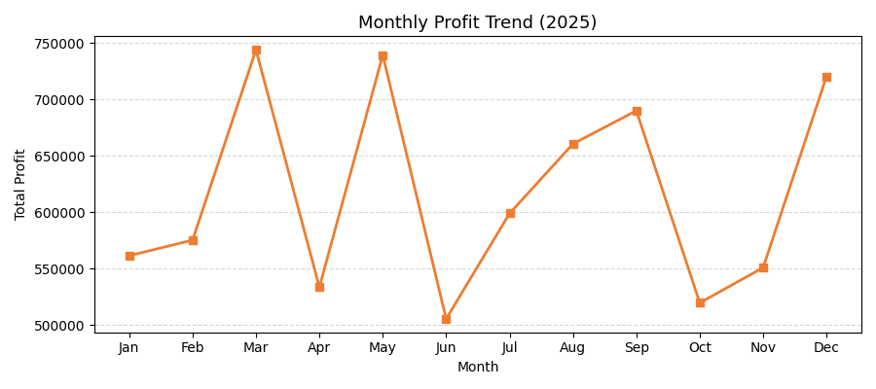

Problem 7: Relationship Between Sales and Profit
Correlation between Sales and Profit: 0.019 (very weak positive correlation)

Observation: Higher sales do not always lead to higher profit. This is a very important finding. The correlation is almost zero, meaning there are other factors like discount percentage and product category that affect profit more than just the sales amount.

Problem 8: Impact of Discount on Profit
Correlation between Discount and Profit: 0.049 (very weak positive correlation)

Observation: Interestingly, higher discounts do not reduce profit in a strong way in this dataset. However this may vary by category. We need to be careful because extremely high discounts on low-margin items like Grocery can erode profit.

Problem 9: Category-wise Sales Contribution
Category | Total Sales | Contribution %
Sports | ~56.5L | 22.65%
Electronics | ~53.1L | 21.26%
Furniture | ~49.5L | 19.83%
Clothing | ~46.1L | 18.47%
Grocery | ~44.5L | 17.79%

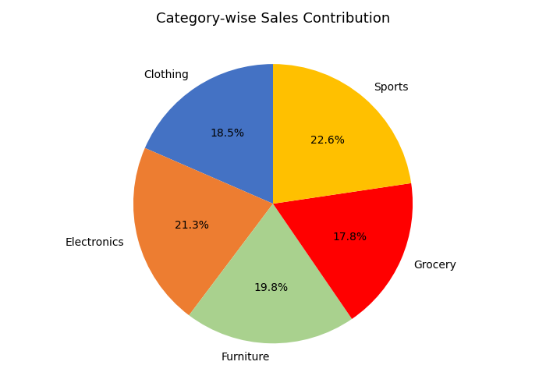

Observation: Sales are fairly evenly distributed across categories with Sports being the top contributor at 22.65% and Grocery at the bottom with 17.79%.

4. Key Findings Summary
1. West region is the highest performing region in terms of total sales.
2. North region has the lowest sales and needs attention.
3. Sports is the most profitable category followed by Clothing.
4. Grocery has the lowest profit and should be reviewed for cost efficiency.

5. March is the best month for both sales and profit.
6. February is the worst month - possibly due to fewer orders after the new year.
7. Sales and Profit are not strongly correlated - high sales orders can have low profit.
8. South gives the highest average discounts which could be impacting margins.

